Task2- Stakeholder Engagement and Communication Plan

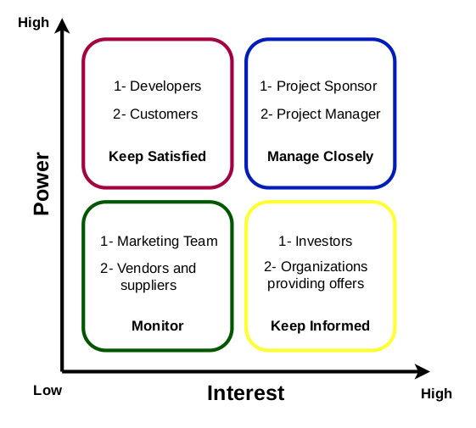

Stakeholders | Unaware | Resistant | Neutral | Supportive | Leading
Customers | C |  | D
Developers |  |  |  | C / D
Project Sponsor |  |  |  | C / D
Project Manager |  |  |  |  | C / D
Organizations | C |  |  | D
Marketing Team |  |  | C | D

C: Current D:Desired

Stakeholders | Way of Communication | Frequency | Topics
Customers | Advertising Campaigns | Daily | Benefits of the product
Developers | Meetings | Weekly | Progress of the project / any required modifications
Project Sponsor | Emails / Meetings | Monthly | Progress of project
Project Manager | Meetings | Weekly | Progress of project
Organizations | Advertising Campaigns | Daily | Benefits of using the product to introduce their offers

